BI

Mini Project

Inventory Management

Table of Contents
1 Introduction 3
1.1 Setup Checklist for Mini Project 3
1.2 Instructions 3
2 Problem Statement 4
2.1 Objective 4
2.2 Abstract of the project 4
2.3 Technology used: 4
3 Implementation in BI LOT 5
3.1 Summary of the functionality to be built: 5
3.2 Guidelines on the functionality to be built: 5

Introduction
This document outlines a mini project for the BI LOT. The project is to develop Analysis & Reporting System of Inventory Management.This document contains the work flow of the system and gives guidelines on how to build the functionality gradually in each of the course modules of the BI LOT.

Setup Checklist for Mini Project
Minimum System Requirements
- Intel Pentium 90 or higher (P166 recommended)
- Microsoft Windows 2010 or Above
- Memory: 4GB of RAM (64MB or more recommended)
- Internet Explorer 10.0 or higher
- Oracle 11g/ SQL Server 2012 or higher
- Informatica 10.2.0 / SSIS / Data Stage/ Abinitio
- Tableau 10 or higher / SSRS / Power BI/ Qlikview

Instructions
- The code modules in the mini project should follow all the coding standards.
- Create a directory by your name in drive <drive>. In this directory, create a subdirectory MiniProject. Store your Project here.
- You can refer to your course material.
- You may also look up the help provided in the BI docs and documentation provided in respective tools.

Problem Statement

Objective
Development of a Analysis & Reporting System of Inventory Management.

Abstract of the project
The project is to develop Analysis & Reporting System of Bank Account Details of the IT Employees

Technology used:
- Oracle 11g / SQL Server (Database)
- Informatica power center / SSIS / Data Stage/ Abinitio(ETL Tool)
- Tableau Desktop / SSRS / Power BI/ Qlikview (Reporting Tool)

Implementation in BI LOT

Summary of the functionality to be built:
The participants need to develop the Analysis & Reporting System of Bank Account Details by building the functionality incrementally in each of the course modules of BI LOT.

Guidelines on the functionality to be built:

Project flow

Heterogeneous Sources i.e. operational data (Flat files)
EXTRACT
TRANSFORM
LOAD
Data warehouse (Oracle)
Reports Based On Universe
UNIVERSE
(Informatica)
(BO IDT)
(BO XI Rich WebI/WebI)

The participants are expected to create a star/snowflake schema model based on the OLTP source files shared with them
The source file has the following data
- Source File 1
  - Date
  - Transaction ID
  - PRODUCT Name
  - PRODUCT Brand
  - Product Model No.
  - Customer Name
  - Seller_ID
  - Product Cost Price
  - Product Selling Price

The OLAP schema diagram is as shown below

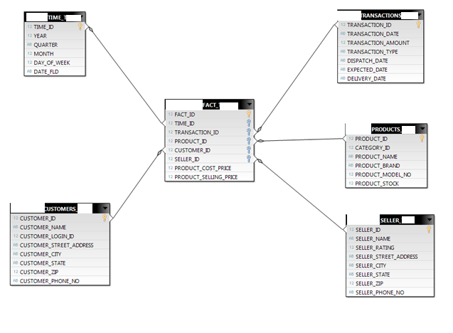

The Dimension tables are
  - Customers
    - CUSTOMER_ID
    - CUSTOMER_NAME
    - CUSTOMER_LOGIN_ID
    - CUSTOMER_STREET_ADDRESS
    - CUSTOMER_CITY
    - CUSTOMER_STATE
    - CUSTOMER_ZIP
    - CUSTOMER_PHONE_NO
  - Products
    - PRODUCT_ID
    - CATEGORY_ID
    - PRODUCT_NAME
    - PRODUCT_BRAND
    - PRODUCT_MODEL_NO
    - PRODUCT_STOCK
  - Seller
    - SELLER_ID
    - SELLER_NAME
    - SELLER_RATING
    - SELLER_STREET_ADDRESS
    - SELLER_CITY
    - SELLER_STATE
    - SELLER_ZIP
    - SELLER_PHONE_NO
  - Time
    - TIME_ID
    - YEAR
    - QUARTER
    - MONTH
    - DAY_OF_WEEK
    - DATE

  - Transaction
    - TRANSACTION_ID
    - TRANSACTION_DATE
    - TRANSACTION_AMOUNT
    - TRANSACTION_TYPE
    - DISPATCH_DATE
    - EXPECTED_DATE
    - DELIVERY_DATE
Fact Tables are
  - Inventory
    - FACT_ID
    - TIME_ID
    - TRANSACTION_ID
    - PRODUCT_ID
    - CUSTOMER_ID
    - SELLER_ID
    - PRODUCT_COST_PRICE
    - PRODUCT_SELLING_PRICE

Note: The datatype/length for the Dimension/Fact table attribues can be changed as required. Additional fields can be added, if required.

- Sample Reports
- Transaction Amount Wise Top 10 Customers
- State wise number of orders
- Preferred mode of payment across states
- Quarterly loss for a particular year
- Quarterly profit for a particular year
- Most preferred seller for a particular product
- Brand analysis of each product
- Quarterly sales count of each product category
Referred to the shared source files.

Sample Reports
Transaction Amount Wise Top 10 Customers

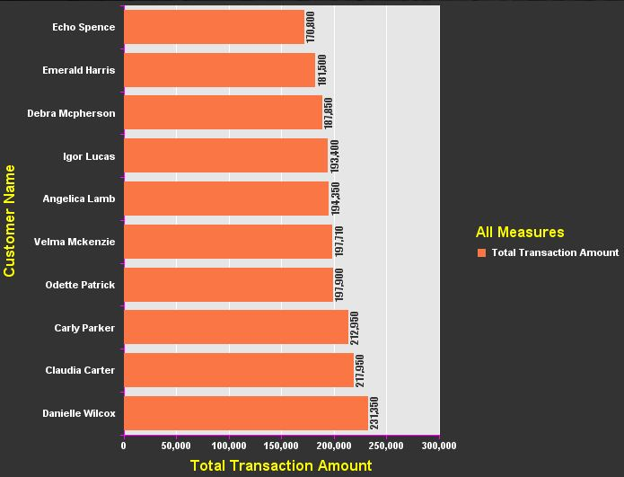

State wise number of orders

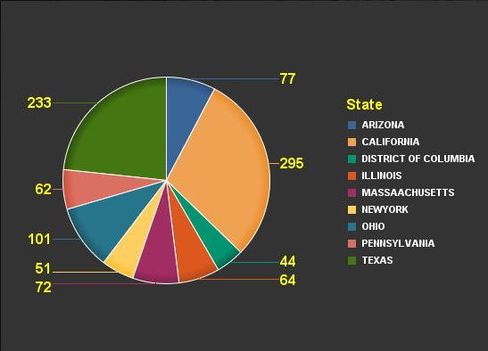

Quarterly loss for a particular year

